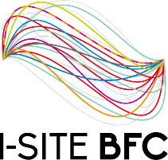

**Université de Franche Comté**

**Radio Networks - RI53**

**Project-CS: Cell selection**

**Report 1– Team 3**

**Done by**

MD AFTAB Uddin, Massilva Boutiab, Mandy-Ann Owusu Manu, Hovhannes Stepanyan

**Supervisor:** Mr. Mabed and Mrs. Baala

May 09, 2022

To start with, we have made up a list of the tasks required of us, as stated in the project, and with the materials given (i.e., pdf and the video).

In other, for us to achieve and deliver an outstanding project to reach the desired deadline, as a group, we have decided to share the work in accord with our diverse backgrounds.

**Points of the list of tasks from the project description**

* Develop a few extensions of this application to familiarize themselves with radio engineering concepts.
* Develop an extension of a network optimization tool.
* Implement a set of tools needed to determine the path taken by the given user equipment and its active/idle periods.
* Implement the selection, reselection, and handover procedures.
* An arrow is to be drawn to link the user equipment to its attached antenna.

**List of Completed Tasks**

* Read, discussed and understood the project given.
* Watched the video given
* Created an edited text document in Google docs for the group

**List of Prospective Tasks**

* Give a functionality of the cell selection
* Define how the mobile interprets the antenna
* Implementations begin
* Clarify our implementation prototype with the network optimization tool.
* Work on the move of the simulation
* Test the application
* Put the project in a document
* Draft a report
* Lastly, get ready for the presentation